Lab 3: Determination of Riboflavin Content in A Multivitamin

Data Analysis

Part B: Absorbance Measurements
- Create an absorbance plot overlaying the collected absorbance spectra of the standards and the unknown. Be sure to label all axes, 𝛌_{max}, and the identity of the solution of each spectrum in a legend. Include a descriptive figure caption below your figure.

- Given the above absorbance data, which wavelength (405 nm or 500 nm) should be used as the excitation wavelength for the fluorescence measurements? Why?

Part C: Fluorescence Measurements
- Create a fluorescence plot overlaying the spectra of all the standards and the unknown trials. Be sure to label all axes, 𝛌_{max}, and the identity of the solution of each spectrum in a legend. Include a descriptive figure caption below your figure.

Question 4 will address the inner filter effect which occurs when the concentration of the analyte is too high, and the excitation beam cannot pass through all of the sample. The fluorescence signal measured is lower than the actual fluorescence of the sample because only the surface of the sample is fluorescing. In a calibration curve, the inner filter effect causes a plateau in the data at high concentrations (Figure A). These high concentrations should be excluded from the calibration curve, because the fluorescence values stray from linearity.
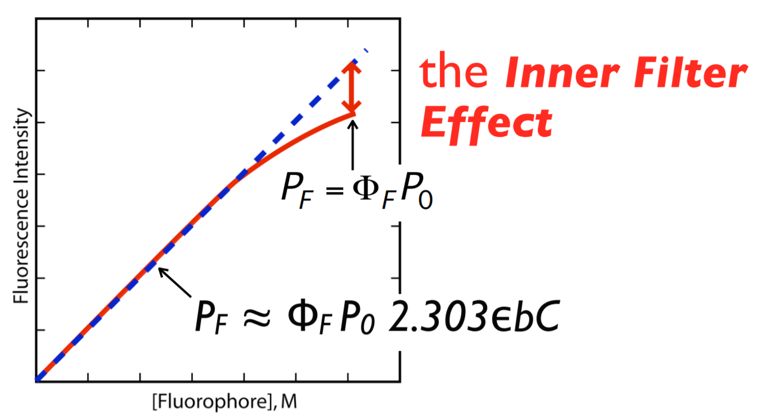
Figure A: Calibration curve illustrating the inner filter effect. The blue dashed line shows a linear relationship between concentration and fluorescence. The red solid line shows data that exhibits the inner filter effect. The inner filter effect is characterized by a plateau at high concentrations and causes a deviation from linearity and a lack of concentration dependence.

- Use the fluorescence data from the standards to answer the following questions:
  - Graph the calibration curve (fluorescence intensity vs. concentration) for all the standards you made and include the equation for line of best fit and R² value. Be sure to label all axes. Include a descriptive figure caption below your figure. What is the range of standard concentration that gives you the most linear calibration curve?

  - Examine your calibration curve in 4a. Do you see evidence of the inner filter effect? If yes, determine which standard solutions are too concentrated and regraph the calibration curve excluding those standards that exhibit the inner filter effect. Include the equation for the line of best fit and R² value. Be sure to label all axes. Include a descriptive figure caption below your figure.

- Report the slope and y-intercept of the more linear calibration curve from Question 4 along with each 95% confidence interval. Use appropriate significant figures and don’t forget units.

- Calculate and report the undiluted unknown riboflavin concentration (in the vitamin solution made in Step A.3) using the more linear calibration curve from Question 4 with the 95% confidence interval. Use appropriate sig figs and don’t forget units.

- Calculate the mass percent of riboflavin in the vitamin sample determined from the calibration curve. Show your work.

Part D: Standard Additions
- Create a plot overlaying the fluorescence spectra of all the standard addition solutions. Be sure to label all axes, 𝛌_{max}, and the identity of the solution of each spectrum in a legend. Include a descriptive figure caption below your figure.

- Graph the standard addition linear curve of fluorescence intensity vs. added volume (mL) and include the equation for line of best fit and R² value. Be sure to label all axes. Include a descriptive figure caption below your figure.

- Report the slope and y-intercept of the standard addition linear curve along with each 95% confidence interval. Use appropriate significant figures and don’t forget units.

- Calculate and report the undiluted unknown riboflavin concentrations (in the vitamin solution made in Step A.3) from the standard addition curve with the 95% confidence interval. Use appropriate sig figs and don’t forget units.

- Calculate the mass percent of riboflavin in the vitamin sample determined from the standard addition curve. Show your work.

Discussion
- Use the multivitamin table information provided in class to determine the theoretical mass percent of riboflavin in the tablet. Calculate your percent error for each method. Show your work.

- Theoretically, which method is better (calibration curve or standard addition curve) for calculating the unknown concentration? Why? What makes this method better?

Instrumentation
- Why is fluorescence spectroscopy more sensitive than absorbance spectroscopy?

- Why can’t we use absorbance spectroscopy to determine the unknown concentration of riboflavin in a multivitamin?

- Which is larger, the excitation wavelength (λ_{ex}) or the emission wavelength (λ_{em})? Why?

- Which position (a,b,c) would it be acceptable to have a fluorescence detector and why?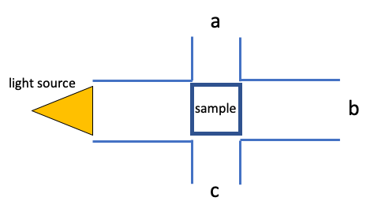

- Using the following diagrams and in your own words, explain the difference between absorbance and fluorescence.

